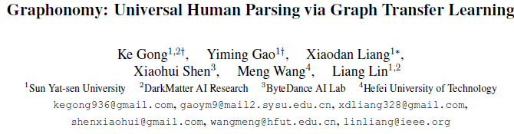

Prior highly-tuned human parsing models tend to fit towards each dataset in a specific domain or with discrepant label granularity, and can hardly be adapted to other human parsing tasks without extensive re-training.

现有方法限于特定领域 或 颗粒度，难用于其他……

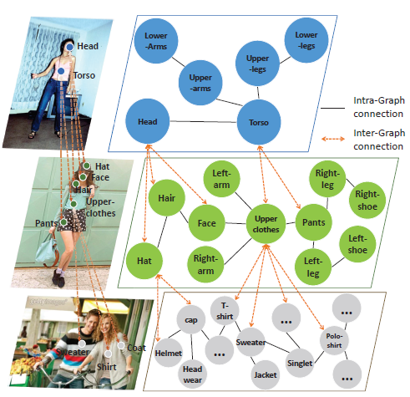

In this paper, we aim to learn a single universal human parsing model that can tackle all kinds of human parsing needs by

**unifying label annotations** from different domains or at various levels of granularity.

通过统一标注（不同领域，不同颗粒度），学出一个通用模型

【挑战】This poses many fundamental learning challenges, e.g. discovering underlying semantic structures among different label granularity, performing proper transfer learning across different image domains, and identifying and utilizing label redundancies across related tasks.

【Idea】To address these challenges, we propose a new universal human parsing agent, named “Graphonomy”, which incorporates hierarchical graph transfer learning upon the conventional parsing network to

提出Graphonomy代理，将 体系图迁移学习 用于改善 图parsing，包括：

encode the underlying label semantic structures and 底层标签语义结构编码

propagate relevant semantic information. 相关语义信息传播

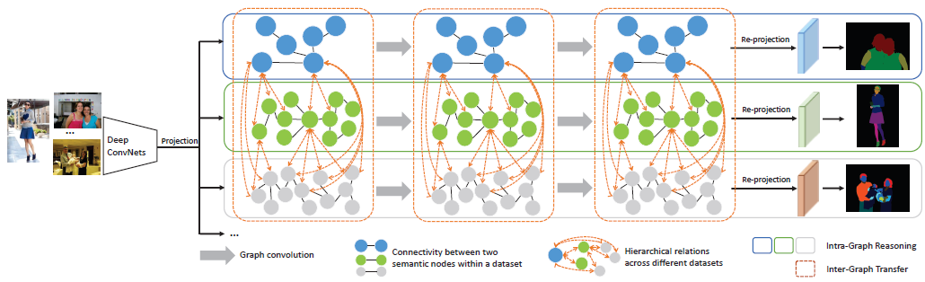

Figure 2. Illustration of our Graphonomy that tackles universal human parsing via graph transfer learning to achieve multiple levels of human parsing tasks and better annotation utilization.

【流程】

a）图像特征，表示为图，节点、边表示身体结构

The image features extracted by deep convolutional networks are projected into a high-level graph representation with semantic nodes and edges defined according to the body structure.

b）全局扩散，不同图之间的推理

The global information is propagated via Intra-Graph Reasoning and re-projected to enhance the discriminability of visual features.

c）图间迁移、融合（实为矩阵转换）

Further, we transfer and fuse the semantic graph representations via Inter-Graph Transfer driven by hierarchical label correlation to alleviate the label discrepancy across different datasets.



Zs 源图矩阵，Zt 目标图矩阵，W 待训练的权重矩阵

During training, our Graphonomy takes advantage of annotated data with different granularity. For inference, our universal human parsing agent generates different levels of human parsing results taking an arbitrary image as input.

【创新点】

1）Graphonomy first learns and propagates compact high-level graph representation among the labels within one dataset via Intra-Graph Reasoning, and then

2）transfers semantic information across multiple datasets via Inter-Graph Transfer. Various graph transfer dependencies (e.g., similarity, linguistic knowledge) between different datasets are analyzed and encoded to enhance graph transfer capability.

3）By distilling universal semantic graph representation to each specific task, Graphonomy

is able to predict all levels of parsing labels in one system without piling up the complexity.

Experimental results show Graphonomy effectively achieves the state-of-the-art results on three human parsing benchmarks as well as advantageous universal human parsing performance.